G1.txt

5

0 1 0 0 0

1 0 0 1 1

0 0 0 0 1

0 1 0 0 0

0 1 1 0 0

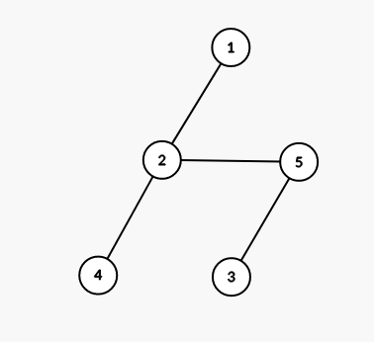

G2.txt

6

0 0 0 0 1 0

0 0 0 0 1 0

0 0 0 1 0 0

0 0 1 0 1 0

1 1 0 1 0 1

0 0 0 0 1 0

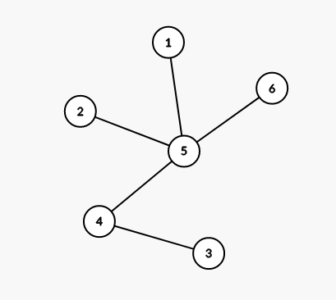

G3.txt

7

0 1 0 1 0 0 0

1 0 0 0 1 0 1

0 0 0 1 0 0 0

1 0 1 0 0 0 0

0 1 0 0 0 0 0

0 0 0 0 0 0 1

0 1 0 0 0 1 0

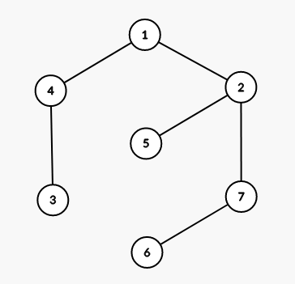

G4.txt

8

0 0 1 0 0 0 0 0

0 0 0 0 0 0 1 0

1 0 0 0 0 0 1 1

0 0 0 0 0 1 0 0

0 0 0 0 0 0 1 0

0 0 0 1 0 0 0 1

0 1 1 0 1 0 0 0

0 0 1 0 0 1 0 0

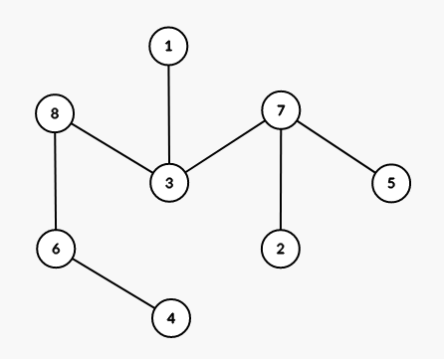

G5.txt

10

0 1 0 1 0 0 0 0 0 0

1 0 0 0 1 0 0 0 0 0

0 0 0 0 0 1 1 0 0 0

1 0 0 0 0 0 1 0 0 0

0 1 0 0 0 0 0 0 0 0

0 0 1 0 0 0 0 0 0 0

0 0 1 1 0 0 0 1 0 0

0 0 0 0 0 0 1 0 0 1

0 0 0 0 0 0 0 0 0 1

0 0 0 0 0 0 0 1 1 0

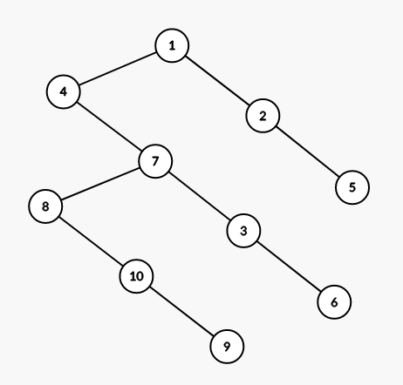

G6.txt

20

0 0 0 0 0 0 0 0 0 0 0 0 0 0 1 0 0 0 0 0

0 0 0 0 0 0 0 0 0 0 0 1 0 0 0 0 0 0 0 0

0 0 0 0 0 0 0 0 0 0 0 1 1 0 0 0 0 0 0 0

0 0 0 0 0 1 1 0 1 0 0 0 0 0 0 0 0 0 0 1

0 0 0 0 0 0 0 0 0 0 0 0 0 0 0 0 0 1 0 0

0 0 0 1 0 0 0 0 0 0 0 0 0 0 0 0 0 0 0 0

0 0 0 1 0 0 0 0 0 0 0 0 0 0 0 0 0 0 0 0

0 0 0 0 0 0 0 0 1 0 1 0 0 0 1 0 0 0 0 0

0 0 0 1 0 0 0 1 0 0 0 0 0 0 0 0 0 0 0 0

0 0 0 0 0 0 0 0 0 0 0 1 0 0 0 0 1 0 0 0

0 0 0 0 0 0 0 1 0 0 0 0 0 0 0 0 0 0 0 0

0 1 1 0 0 0 0 0 0 1 0 0 0 0 0 0 0 0 0 0

0 0 1 0 0 0 0 0 0 0 0 0 0 0 1 0 0 0 0 0

0 0 0 0 0 0 0 0 0 0 0 0 0 0 1 0 0 0 0 0

1 0 0 0 0 0 0 1 0 0 0 0 1 1 0 0 0 0 0 0

0 0 0 0 0 0 0 0 0 0 0 0 0 0 0 0 0 1 0 1

0 0 0 0 0 0 0 0 0 1 0 0 0 0 0 0 0 0 1 0

0 0 0 0 1 0 0 0 0 0 0 0 0 0 0 1 0 0 0 0

0 0 0 0 0 0 0 0 0 0 0 0 0 0 0 0 1 0 0 0

0 0 0 1 0 0 0 0 0 0 0 0 0 0 0 1 0 0 0 0

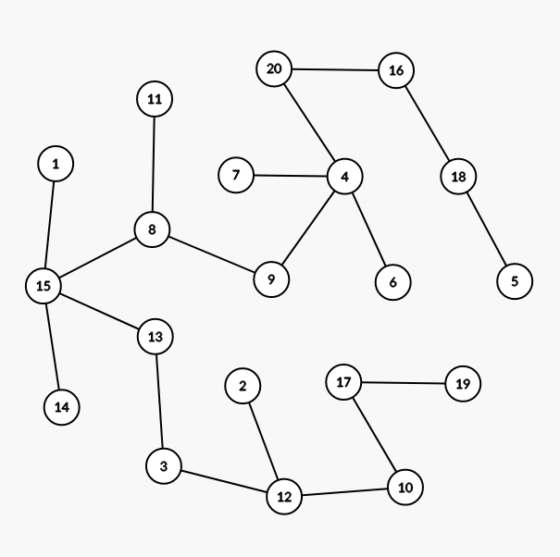

G7.txt

20

0 0 0 0 0 1 0 0 0 0 0 1 0 0 0 0 0 0 0 0

0 0 0 0 1 0 0 0 0 0 1 0 0 0 0 0 0 0 0 0

0 0 0 0 1 0 0 0 0 0 0 0 0 0 0 0 0 0 0 1

0 0 0 0 0 0 0 0 1 0 0 0 0 0 0 0 1 0 0 0

0 1 1 0 0 0 0 0 0 0 0 0 0 0 0 0 0 0 0 0

1 0 0 0 0 0 0 0 0 0 0 0 0 1 0 0 0 0 0 0

0 0 0 0 0 0 0 0 0 0 0 0 1 0 0 0 0 0 0 1

0 0 0 0 0 0 0 0 0 0 0 0 0 0 0 1 0 0 0 0

0 0 0 1 0 0 0 0 0 0 0 0 0 0 0 0 0 0 0 0

0 0 0 0 0 0 0 0 0 0 0 0 0 1 1 0 1 0 0 0

0 1 0 0 0 0 0 0 0 0 0 0 0 0 0 0 0 0 1 0

1 0 0 0 0 0 0 0 0 0 0 0 0 0 0 1 0 0 0 0

0 0 0 0 0 0 1 0 0 0 0 0 0 0 0 0 0 1 0 0

0 0 0 0 0 1 0 0 0 1 0 0 0 0 0 0 0 0 0 0

0 0 0 0 0 0 0 0 0 1 0 0 0 0 0 0 0 0 0 0

0 0 0 0 0 0 0 1 0 0 0 1 0 0 0 0 0 0 0 0

0 0 0 1 0 0 0 0 0 1 0 0 0 0 0 0 0 1 0 0

0 0 0 0 0 0 0 0 0 0 0 0 1 0 0 0 1 0 0 0

0 0 0 0 0 0 0 0 0 0 1 0 0 0 0 0 0 0 0 0

0 0 1 0 0 0 1 0 0 0 0 0 0 0 0 0 0 0 0 0

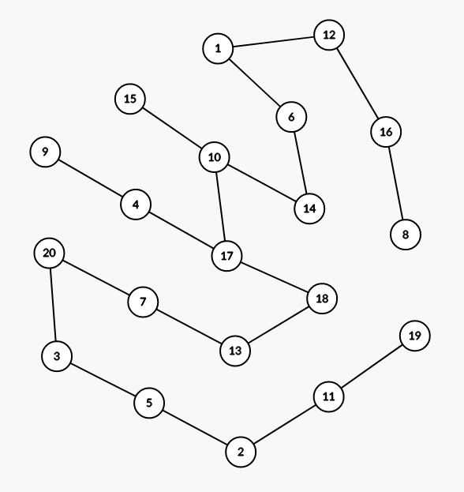

G8.txt

20

0 0 0 0 0 0 0 0 0 0 1 0 0 0 0 0 0 0 0 0

0 0 0 0 0 0 0 0 1 1 0 0 0 0 0 0 0 0 0 0

0 0 0 0 0 0 0 0 0 0 1 0 1 0 0 0 1 0 0 0

0 0 0 0 0 0 0 0 0 0 0 0 0 0 0 0 0 1 0 1

0 0 0 0 0 0 0 0 1 0 0 0 0 0 0 0 0 0 0 0

0 0 0 0 0 0 0 0 0 1 0 1 0 0 0 0 0 0 0 0

0 0 0 0 0 0 0 0 0 0 0 1 1 0 0 0 0 0 0 0

0 0 0 0 0 0 0 0 1 0 0 0 0 0 0 0 0 0 0 0

0 1 0 0 1 0 0 1 0 0 0 0 0 0 0 0 0 0 0 0

0 1 0 0 0 1 0 0 0 0 0 0 0 0 0 0 0 0 1 0

1 0 1 0 0 0 0 0 0 0 0 0 0 0 0 0 0 0 0 0

0 0 0 0 0 1 1 0 0 0 0 0 0 0 1 0 0 0 0 0

0 0 1 0 0 0 1 0 0 0 0 0 0 0 0 0 0 0 0 0

0 0 0 0 0 0 0 0 0 0 0 0 0 0 0 0 1 0 0 1

0 0 0 0 0 0 0 0 0 0 0 1 0 0 0 1 0 0 0 0

0 0 0 0 0 0 0 0 0 0 0 0 0 0 1 0 0 0 0 0

0 0 1 0 0 0 0 0 0 0 0 0 0 1 0 0 0 0 0 0

0 0 0 1 0 0 0 0 0 0 0 0 0 0 0 0 0 0 0 0

0 0 0 0 0 0 0 0 0 1 0 0 0 0 0 0 0 0 0 0

0 0 0 1 0 0 0 0 0 0 0 0 0 1 0 0 0 0 0 0

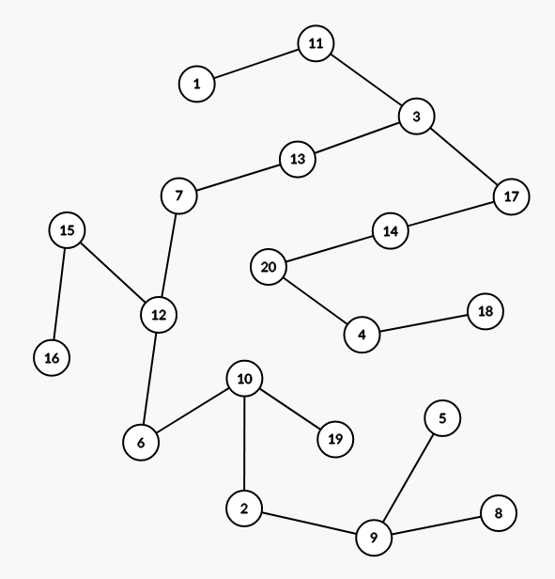

G9.txt

20

0 0 0 0 0 1 1 1 0 0 0 0 0 0 0 0 0 0 0 1

0 0 0 0 0 0 0 0 0 0 1 0 0 0 0 0 0 0 0 0

0 0 0 0 0 0 0 0 0 0 0 0 0 0 0 0 1 0 0 0

0 0 0 0 0 0 0 0 1 0 0 0 0 0 0 0 0 1 0 0

0 0 0 0 0 0 0 0 0 1 0 0 0 0 0 0 1 0 0 0

1 0 0 0 0 0 0 0 0 0 0 0 1 0 0 0 0 0 0 0

1 0 0 0 0 0 0 0 0 0 0 0 0 0 0 0 0 0 0 0

1 0 0 0 0 0 0 0 0 1 0 0 0 0 0 0 0 0 0 0

0 0 0 1 0 0 0 0 0 0 0 0 0 0 0 0 0 0 0 0

0 0 0 0 1 0 0 1 0 0 0 0 0 0 0 0 0 0 1 0

0 1 0 0 0 0 0 0 0 0 0 0 0 1 1 0 0 0 0 0

0 0 0 0 0 0 0 0 0 0 0 0 1 0 0 1 0 1 0 0

0 0 0 0 0 1 0 0 0 0 0 1 0 0 0 0 0 0 0 0

0 0 0 0 0 0 0 0 0 0 1 0 0 0 0 0 0 0 0 0

0 0 0 0 0 0 0 0 0 0 1 0 0 0 0 1 0 0 0 0

0 0 0 0 0 0 0 0 0 0 0 1 0 0 1 0 0 0 0 0

0 0 1 0 1 0 0 0 0 0 0 0 0 0 0 0 0 0 0 0

0 0 0 1 0 0 0 0 0 0 0 1 0 0 0 0 0 0 0 0

0 0 0 0 0 0 0 0 0 1 0 0 0 0 0 0 0 0 0 0

1 0 0 0 0 0 0 0 0 0 0 0 0 0 0 0 0 0 0 0

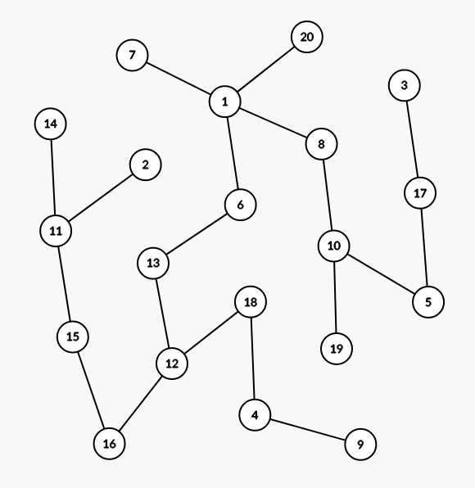

G10.txt

20

0 0 0 0 0 0 1 0 0 0 0 0 1 0 0 0 0 0 0 0

0 0 0 1 0 0 0 0 0 0 0 0 0 0 1 0 0 0 0 0

0 0 0 0 0 0 0 0 0 0 0 0 0 0 0 1 0 1 0 0

0 1 0 0 0 0 0 0 0 0 0 1 0 0 0 0 0 0 0 0

0 0 0 0 0 0 0 0 0 0 0 0 0 0 0 0 0 0 0 1

0 0 0 0 0 0 0 0 1 0 0 0 0 1 1 0 0 0 0 0

1 0 0 0 0 0 0 0 0 0 0 0 0 0 0 0 0 1 0 0

0 0 0 0 0 0 0 0 0 1 0 0 0 0 0 0 0 0 0 0

0 0 0 0 0 1 0 0 0 0 0 0 0 0 0 0 0 0 0 0

0 0 0 0 0 0 0 1 0 0 0 0 0 0 0 0 1 0 0 0

0 0 0 0 0 0 0 0 0 0 0 0 0 0 0 0 1 0 0 1

0 0 0 1 0 0 0 0 0 0 0 0 0 0 0 1 0 0 0 0

1 0 0 0 0 0 0 0 0 0 0 0 0 0 0 0 0 0 1 0

0 0 0 0 0 1 0 0 0 0 0 0 0 0 0 0 0 0 0 1

0 1 0 0 0 1 0 0 0 0 0 0 0 0 0 0 0 0 0 0

0 0 1 0 0 0 0 0 0 0 0 1 0 0 0 0 0 0 0 0

0 0 0 0 0 0 0 0 0 1 1 0 0 0 0 0 0 0 0 0

0 0 1 0 0 0 1 0 0 0 0 0 0 0 0 0 0 0 0 0

0 0 0 0 0 0 0 0 0 0 0 0 1 0 0 0 0 0 0 0

0 0 0 0 1 0 0 0 0 0 1 0 0 1 0 0 0 0 0 0

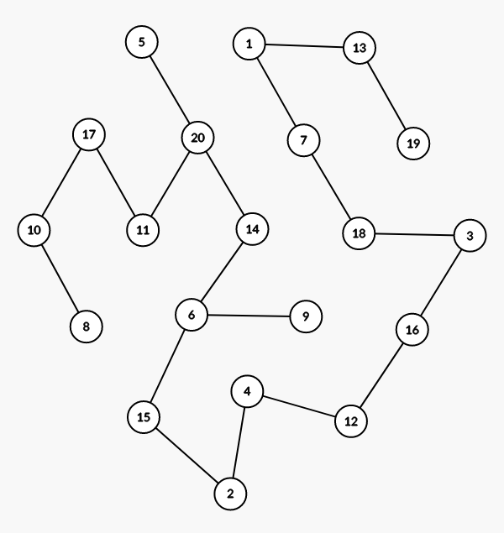

G11.txt

4

0 1 0 0

1 0 1 0

0 1 0 1

0 0 1 0

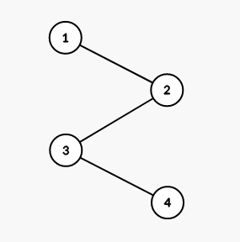

G12.txt

4

0 1 1 0

1 0 0 1

1 0 0 0

0 1 0 0

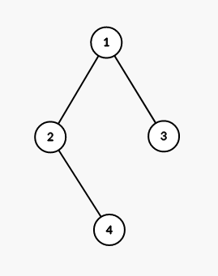

G13.txt

4

0 1 0 0

1 0 1 1

0 1 0 0

0 1 0 0

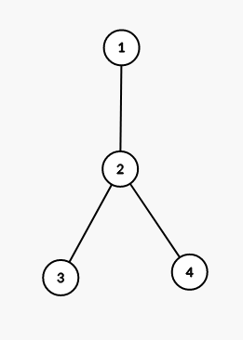

G14.txt

4

0 1 1 1

1 0 0 0

1 0 0 0

1 0 0 0

